A
PROJECT REPORT
ON

“AMAZON PANTRY”
AT
AMAZON DEVELOPMENT CENTER PVT LTD
BY
ASHAB AZIZ SHAIKH

UNDER THE GUIDANCE OF
MR MOHAMMAD ALI
SUBMITTED TO
SAVITRIBAI PHULE PUNE UNIVERSITY

IN THE PARTIAL FULFILLMENT OF THE REQUIREMENTS FOR THE AWARD
OF
THE DEGREE OF

MASTERS OF BUSINESS ADMINISTRATION
FOR THE ACADEMIC YEAR 2022-2023

POONA INSTITUTE OF MANAGEMENT SCIENCES AND ENTREPRENEURSHIP.
PUNE – 411001
PREFACE

This project has information on the given topic “AMAZON PANTRY”. I had visited “AMAZON DEVELOPMENT CENTER PVT LTD” and surf through the internet to get more information on my topic for making my project going through this information was really interesting and knowledgeable, this report consist of how Business Analysis work is done for development of a new business process and data visualization for better interpretation of data and decision making at Amazon Development Center Pvt Ldt. I hope the contents of this report will give the reader a quick look on the company’s business analytics & data analysis process, Data visualization for quick insights on critical business decisions.
As a student of POONA INSTITUTE OF MANAGEMENT SCIENCES AND ENTREPRENEURSHIP, I have been assigned to make the Project Report on “Amazon Pantry” from the practical exposure I have gone through at “Amazon Development Center Pvt Ldt”,
I have tried my best with my ability to complete this with appropriateness.
DECLARATION

I, ASHAB AZIZ SHAIKH, hereby declare that the Project report entitled “AMAZON PANTRY” written and submitted by me to the University of Pune, in partial fulfillment of the requirement for the Master of Business Administration.
All the endeavors put in the fulfillment of the task are genuine and original to best of my knowledge. The report presented to College & University is purely genuine and it has not been presented earlier.

Place: Pune
Date: Ashab Shaikh
ACKNOWLEDGEMENT

I express my sincere thanks to my project guide, Mr Mohammad Ali
director of management studies for guiding me right from the inception till the successful completion of the project. I sincerely acknowledge them for extending their valuable guidance, support for literature, critical reviews of project and the report and above all the moral support they provided to me at all stages of this project.
I would like to express big thanks to Dr. Porinita Banerjee for their all-time support and time to time guidance. Their experience, knowledge and support lead me to complete my project timely and successfully.
My thanks are due to all those who have indirectly or directly helped me in preparing this project report. However, I accept the sole responsibility for any possible errors or omission and would be extremely grateful to the readers of this project report if they bring such mistakes to my notice.

INDEX  CH. NO. | TOPIC | PAGE NO.
1 | EXECUTIVE SUMMARY | 6-8
2 | ORGANIZATION PROFILE | 9-13
3 | OUTLINE OF THE PROBLEM / TASK UNDERTAKEN | 14-18
4 | RESEARCH METHODOLOGY AND DATA ANALYSIS | 19-30
5 | RELEVANT ACTIVITY, CHARTS, TABLES AND DAIGRAMS | 31-33
6 | LEARNING THROUGH THE PROJECT | 34-34
7 | CONTRIBUTION TO THE HOST ORGANIZATION | 35-35
8 | REFERNCE | 36-37

1. EXECUTIVE SUMMARY

EXECUTIVE SUMMARY
Amazon.com is a customer centric company. They put more effort in improving their system to make the experience of customer more comfortable so that he keeps on returning to the website. Jeffery Bezos who is the founder of the Amazon.com started this company after seeing the use of internet increasing rapidly.
The company was started in year 1994. According to Bezos, the company tries to solve a very hard problem by understanding how can they serve the consumer better and thus try to convert the problem into straight forward problem. According to Bezos, amazon.com doesn’t make money when they sell, but they make money when they help customers in choosing the product they want to buy.
Amazon is a fortune 500 company that has revolutionized the retail industry , In recent years Amazon has faced increased competition in highly competitive online retail space.
So to grow further more and take advantage of its high customer based online retail company , Amazon has taken over to add/build a new feature or project which is Amazon Pantry.
Amazon Pantry will let customers buy Groceries and household products in various sizes that are cost prohibitive to deliver for free. For this there will be a charge of rupees 30 for prime members and 50 for non prime members
Customers can explore variety of Health care Products , Groceries and household products on Lower price , Pay on delivery , from top brands with Best deals, No cost EMI , huge selection range , one day delivery and great offers in this competitive environment. Amazon Inc. is a very expansive company encompassing a vast variety of products, services, and technological advancements.

Amazon has continued to strategically place itself at the fore front of business development. As the power of the internet continues to develop Amazon will evolve to continue to utilize the internet to capture market share across its many different product categories.

This initial launching of Amazon Pantry is the basis for establishing a larger hard infrastructure network in a region where Amazon lacked an operational presence. It costs $4.40 (US dollar) to deliver an order below $29.50, and $7 for all one-hour delivery.
Marketing research specifies the information required to address these issues, designs the method for collecting information, manages and implements the data collection process, analyzes the results, and communicates the findings and their implications market with strong team..
Consumers are our best source of business information - whether it's to improve an existing product or service or whether you're planning to launch something new and you often can make changes or launch products more quickly.

A greater importance is also placed on consumer retention, customer relationship management, personalization, customization and one-to-one marketing. Social functions can be categorized into social choice and welfare functions.

2. ORGANIZATION PROFILE
ORGANIZATION PROFILE
AMAZON
Amazon.com, Inc, doing business as Amazon, is an American electronic commerce and cloud computing company based in Seattle. Washington that was founded by Jeff Bezos on July 5, 1994. The tech giant is the largest Internet retailer in the world as measured by revenue and market capitalization, and second largets after Alibaba Group in terms of total sales. The amazon.com website started as an online bookstore and later diversified to sell videos downloads/ streaming, MP3 downloads/ streaming, audio book downloads/streaming, software, video games, electronics, apparel, furniture, food, toys, and jewellery. The company also produces consumer electronics- kindle e-readers. Fire tablets, Fire TV, and Echo-and is the world's largest provider of cloud infrastructure services (IaaS and PaaS). Amazon also sells certain low-end products under its in-house brand Amazon Basics.
Amazon has separate retail websites for the United States, the United Kingdom and Ireland, France, Canada, Germany, Italy, Spain, Netherlands, Australia, Brazil, Japan, China, India, and Mexico, hi2016, Dutch, Polish and Turkish language versions of the German Amazon website were also launched. Amazon also offers international shipping to certain other countries for some of its products.

In 2015, Amazon surpassed Walmart as the most valuable retailer in the United States by market capitalization. Amazon is the fourth most valuable public company in the world. the largest Internet company by revenue in the world, and the eighth largest employer in the United States. In 2017, Amazon acquired Whole Foods Market for $13.4 billion, which vastly increased Amazon's presence as a brick-and-mortar retailer. The acquisition was interpreted by some as a direct attempt to challenge Walmart's traditional retail stores.
The company was founded as a result of what Jeff Bezos called his "regret minimization framework," which described his efforts to fend off any regrets for not participating sooner in the Internet business boom during that time.
Amazon was incorporated in 1994 in Washington State. In July 1995, the company began service and sold its first book on Amazon.com: Douglas Hofstadter's Fluid Concepts and Creative Analogies: Computer Models of the Fundamental Mechanisms of Though. In October 1995, the company announced itself to the public. IN 1996, it was reincorporated in Delaware. Amazon issued its initial public offering of stock on May 15, 1997, trading under the NASDAQ stock exchange symbol AMZN, at a price of US$18.00 per share ($1.50 after three stock splits in the late 1990s).
Since June 19, 2000. Amazon's logotype has featured a curved arrow leading from A to Z, representing that the company carries every product from A to Z. with the arrow shaped like a smile.

72011. Amazon had 30,000 full-time employees in the USA, and by the end of 2016, it had 180.000 employees. The company employs 306.800 people worldwide in full part-time jobs.
On October 11, 2016, Amazon announced plans to build convenience stores and develop curbside pickup locations for food. In December 2016, the Amazon Go store was opened to Amazon employees in Seattle. The store uses a variety of sensors and automatically charges a shopper's Amazon account as they walk out of the store, eliminating the need for checkout lines. The store is planned to open for the general public in early 2017.

In June 2017, Amazon announced that it would acquire Whole Foods, a high-end supermarket chain with over 400 stores, for $ 3.4 billion. The acquisition seen by media experts as a move to strengthen its physical holdings and challenge Walmart's supremacy as a brick and mortar retailer. This sentiment was heightened by the fact that the announcement coincided with Walmart's purchase of men's apparel company Bonobos. On August 23 , 2017, Whole Foods shareholders, as well as me Federal Trade Commission. approved the Federal Trade Commission, approved the deal.

In September 2017, Amazon announced plans to locate a second headquarters in a metropolitan area with at least a million people. Cities needed to submit their presentations by October 19, 2017 for the project called HQ2 The $5 billion second headquarters., starting with 500,000 square feet and! eventually expanding to as much as 8 million square feet, may have as many as 50,000 employees.
In 2020. Amazon will build a new downtown Seattle building with space for Mary's Place, a local charity: Amazon.com operates retail websites for Sears Canada. Bebe Stores, Marks & Spencer, Mothercare, and Lacoste. For a growing number of enterprise clients, including the UK merchants Marks & Spencer, Benefit Cosmetics' UK entity, edeals.com and Mother care, Amazon provides a unified multichannel platform where a customer can interact with the retail website, standalone in-store terminals or phone-based customer service agents.

On October 18, 2011, Amazon.com announced a partnership with DC Comics for the exclusive digital rights to many popular comics, including Superman Batman. Green Lantern, The Sandman, and Watchmen. The partnership has caused well-known bookstores like Barnes & Noble to remove thesis titles from their shelves.
In November 2013, Amazon.com announced a partnership with the United States Postal Services to begin delivering orders on Sundays. The service, included in Amazon's standard shipping rates, initiated in metropolitan areas of Los Angeles and New York due to the high-volume and inability to deliver timely, with plans to expand into Dallas. Houston. New Orleans and Phoenix by 2014.

In July 2016, Amazon.com announced a partnership with the U.K.Civil Aviation Authority to test some of the technologies and may use delivery service via prime air drone in the future.

Amazon is the largest internet based company in the united states. Amazon has separate retail websites for United States, United Kingdom & Ireland. France, Canada, Germany, the Netherlands, Italy, Spain, Australia, Brazil, Japan, China, India and Mexico, with sites for Sri Lanka and South East Asian Countries coming soon. Amazon also offers international shipping to certain other countries for some of its products.

In the year 2011, it had professed an intention to launch its websites in Poland, and Sweden. In early June 2013, Amazon.com had launched their Amazon India marketplace without any marketing campaigns. In July, 2013, Amazon had announced to invest $2 billion (Rs 12000 crores) in India to expand business, after its largest Indian rival Flipkart too announced to invest $1 billion. Amazon.com started as an online bookstore, but soon; diversified. selling dvds, vhss, cds, video and mp3, downloads streaming, software, video games, electronics, apparel, furniture, food, toys and jewellry. The company also produces consumer electronics notably, kindle, fire tablets, fire tv and phone and is a major provider of cloud computing services.
.

3. OUTLINE OF THE PROBLEM

OUT LINE OF PROBLEM / TASK UNDERTAKEN:
Enhancement of Amazons App or website to include new feature called AMAZON PANTRY

- Current State of Amazon
Overview and Summary
Amazon is the world’s leading online e-commerce company. They started by selling books and now have a presence across the world selling more than 6 million items globally.
Most of the products that dominate Amazon’s sales are non-essential products like fashion products, electronic gadgets, mobile phones, beauty products, books and home furnishings. But Amazon has realized that every household will need daily essential products like cereals, snacks, beverages, cleaning products, grooming products and so on. Amazon is seeing a huge market globally in Daily Essential Products and wants to venture into this side of business.
Amazon decided to create a new feature known as AMAZON PANTRY which would sell daily essential products. This would be an additional enhancement in the current website/app. This would be Amazon’s foray into daily essential products which are regular consumption products and would lead to repeat sales every month.

- Future State of Amazon
Amazon has the following requirements:
- Existing system should have a new feature called Amazon Pantry
- On clicking this feature, it would open up a new range and categories of products.
- This feature should be at a prominent visible area of the existing website or app.
There should be a logical grouping of products for customers to search for daily essential items they wish to buy. The following categories should be included: Flour and rice
- Sugar, salt, and spices
- Pulses
- Personal care
- Snacks
- Hand wash and sanitizers
- Household cleaning essentials
- Breakfast food items
- Tea and coffee
- Baby care
- Female hygiene
- Tissues
- fresheners
- Amazon Pantry should be able to show five advertisements to earn the advertising revenues. These advertisements should not be too intrusive to spoil the customer interaction with Amazon Pantry.
- Amazon Pantry should have a feature to show certain offers that are created for customers. They have found that many customers tend to buy products under the offers laid out by them.
- Customers should be able to add these items to their shopping cart. This cart may have items from Amazon nonessential products as well.
- The software should not allow the user to place an order of an amount less than 30 USD. Individual items can be less than 30 USD but the total order price has to exceed 30 USD.
- Free Delivery will be offered only if the total order exceeds 50 USD.
- Currently Amazon Pantry would have a presence only in certain cities that are mentioned in the data sets.
- In the US Market, Amazon has categorized cities into 4 zones based on their sales in that city. Cities falling under zone 1 have the highest sales. The sales in various zones are zone 1 > zone 2 > zone 3 > zone 4
- Management wants certain reports at the end of the day. Please give the report formats for the following reports:
- Total sales for each day
- Total sales for each product category as mentioned in point four.
- Total sales across USA
- Total sales for each city.
- Total sales for each zone that city falls into (that is, zone 1, 2, 3, and 4)
- Identify best-selling categories
- Identify the worst-selling categories
- Total sales of each week city wise
- Identify which day of the week shows highest booking by customers

Project Task: Week 1 (BUSINESS ANALYSIS)

- Identifying Stakeholders – Create a list of Stakeholders as per in Business Analysis Planning and Monitoring Knowledge Area
- Create As-Is and Future Process map (using flowcharts) with the use any of the popular tools in the market like Microsoft Visio, Lucid Chart, Creately, Pidoco, or Balsamiq
- As a Business Analyst working on this project, find out the scope of the feature Amazon Pantry. Write down the main features that need to be developed.
- Write the in-scope and out-of-scope items for this software.
- Write out the business requirements, both functional and non-functional Requirements
- Draw wireframes or mock screens for any two of the features. Use the technique prototyping or wire framing. With the help of wire framing tools like Microsoft PowerPoint, Microsoft Word, Balsamic, Sketch, Adobe XD, Adobe Illustrator, Figma, UXPin, InVision Studio, Invision Freehand, or Moqups.
Project Task: Week 2 (AGILE METHODOLOGY)

- Make a product backlog of user stories for the given case study. User Stories should be in the format of As a <type of user>, I want <goal> so that <reason>
- For each story, write the acceptance criteria.

Project Task: Week 3 (TABLEAU)
Create a dashboard for senior management for Chicago to view sales of personal care products for the last 6 months. Make assumptions as appropriate and create the dashboard using your own mock data. For any missing data make your assumptions to create mock data. Write down the assumptions as well.
- Create a dashboard to show Senior Management for Chicago to view sales of breakfast products for the last six months. Make assumptions as appropriate and create the dashboard using your own mock data. For any missing data make your assumptions to create mock data. Write down the assumptions as well.
Project Task: Week 4 ( EXCEL)
- Question 1:
1. Create a bar graph showing the sales. Label the chart correctly so that senior management gets a clear report of sales.
2. Arrange the data above in excel in ascending and descending order.

- Question 2
1. Create bar graphs of sales for zone 1 cities
2. Find total sales across all cities

- Question 3
1. Using vlookup for product code HS, find sales in Phoenix
2. Using vlookup for product code FR, find sales in Dallas

4. RESEARCH METHODOLOGY & DATA ANALYSIS
AMAZON PANTRY
Research methodology used for the project is Business Analysis standard Practices with the use of Agile methodology and use of visualization tools such as Word, Tableau and Excel

1. Identifying Stakeholders:

  ACTOR
  What he can do on the Software Created
  - Customer
  - Register and login to system.
  - View different categories of essential and non-essential items.
  - View advertisements and offers.
  - Select the items.
  - Add items to shopping cart.
  - View total shopping cart.
  - Choose payment method.
  - Delivery Man
  - Check the list of delivery order to the desired location.
  - Close the order after delivery.
  - Tester
  - Tester will test the before deployment
  - Business Analyst
  - Ensure all the requirements were cover and check communication between all the stakeholders.
  - Management
  - View reports at the end of the day.
  - View monthly Sales and Revenue.
  - View feedback and customers satisfaction.

Stake Holder Matrix:
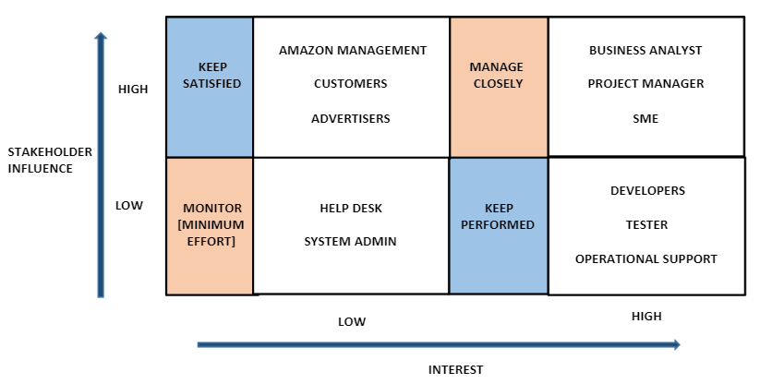
RACI Matrix for Pantry Development:
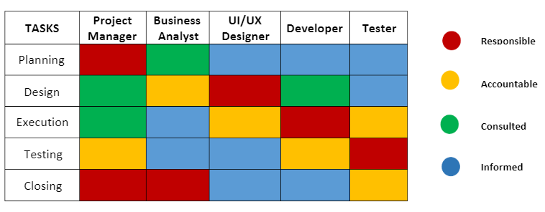

2. As-Is and Future Process

Future Process map:
Context Diagram:

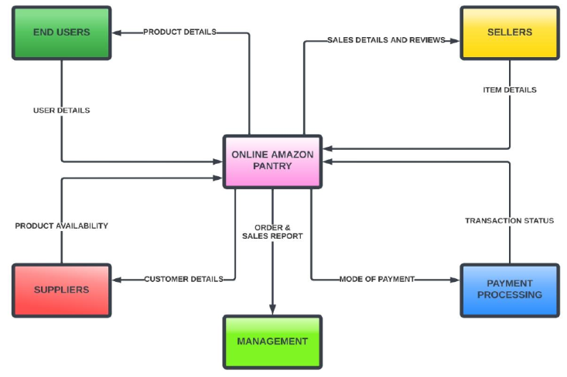

3. Scope of the feature Amazon Pantry. The main features that need to be developed:

- Add more items based on customers need.
- Add pick up option for the order.
- Send adv and offers for customers by email.
- Add cancel option for order.
- Items should be arranged in ascending and descending Order.
- For pantry order should be delivering in shortest time.

4. Write the in-scope and out-of-scope items for this software.
- In-scope:
- Register and login to system.
- View different categories of essential and non-essential items.
- View advertisements and offers.
- Select the items and add it to shopping cart.
- View total shopping cart.
- Choose payment method.
- No order of an amount less than 30 USD.
- Free Delivery if the total order exceeds 50 USD.
- Generate report.

- Out-of-scope:
- The system will not be able to register a new customer to the system.
- Facilities for people with special needs.
- Discount for second order.
- Membership.

5.The business requirements, both Functional & Non Functional
- Functional Requirements :

- User should be able to register and login to the system.
- The system should keep records of different categories of items.
- The system should have new feature known as ABC Pantry.
- The system should have logical grouping of products.
- The system should have five advertisements.
- The system should have a feature to show certain offer.
- User should be able to add items to shopping cart.
- The system should not allow the user to place order of an amount less than 30 USD.
- The system should have Free Delivery only if the total order exceeds 50 USD.
- The system should generate reports at the end of the day.
- Total sales for each day
- Total sales for each product category as mentioned in point four.
- Total sales across USA
- Total sales for each city.
- Total sales for each zone that city falls into (that is, zone 1, 2, 3, and 4)
- Identify best-selling categories
- Identify the worst-selling categories
- Total sales of each week city wise
- Identify which day of the week shows highest booking by customers

- Non-functional Requirements:

- Highly secure, scalable, and reliable
- The screens should be self-explanatory and very user friendly.
- System should be had regular maintenance.
- The site should load in 3 seconds.
- Data should be stored in cloud

6. Wireframes or mock screens for the features:
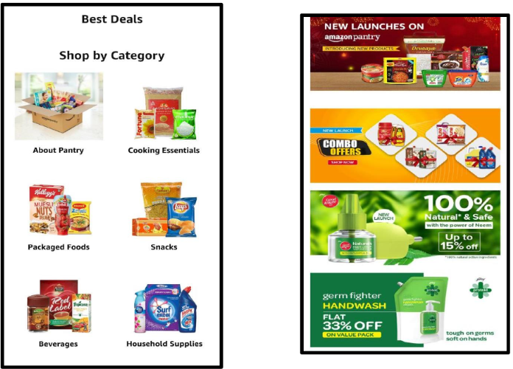

AGILE METHODOLOGY
1. Product backlog of user stories for the given case study:

Product Backlog | Acceptance Criteria
 | The user can access the application with valid information otherwise no account created.
  As a user I want to create an account so that I can use amazon shopping.
 | A user is able to change password if he does not remember password or he want to change it so if he remembers old password or send link to reset new password.
  As a user I want to reset password so that I can change password if I don’t remember.
 | A user is able to enter specific items on search option and find the items.
  As a user I want to search the items so that I can lookup items and prices.
 | A user is able to view shopping cart and he can edit/delete items
  As a user I want to view shopping cart so that I can check and modify my order. | .
 | As items collector is able to view order and their quantity.
  As items collector I want an accurate order data so that I can easily find items and their quantity.
As delivery man I want to view the orders and locations to easy delivery. | A delivery man is able to view orders and their locations.
As Management I want sales reports at end of the day so that I can make decision.
  The management are able to generate sales report.

2. For each story, write the acceptance criteria:
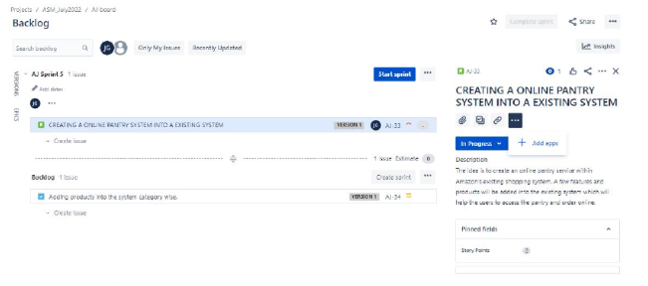
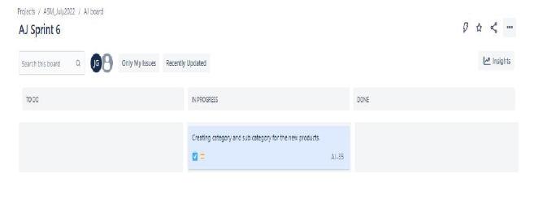
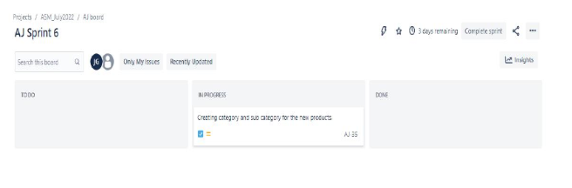
5. RELEVANT ACTIVITY, CHARTS, TABLES AND DAIGRAMS

DATA SETS FOR THE PROJECT
1. TABLEAU DATA
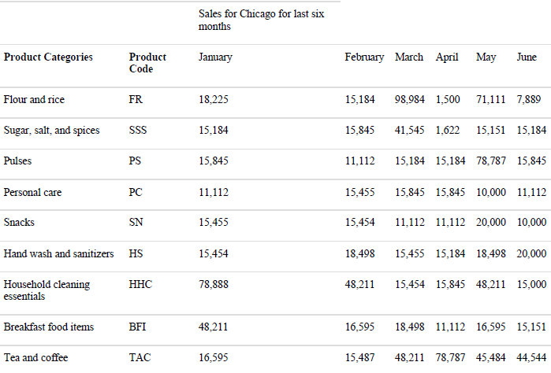
1.1Sales for Chicago product category wise for last 6 months
2 EXCEL DATA
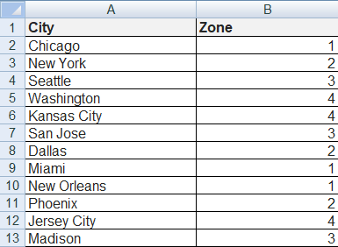
2.1..City wise zone number
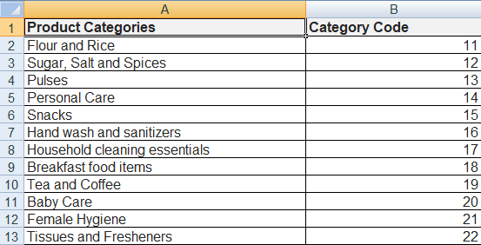
2.2. Product Category Codes

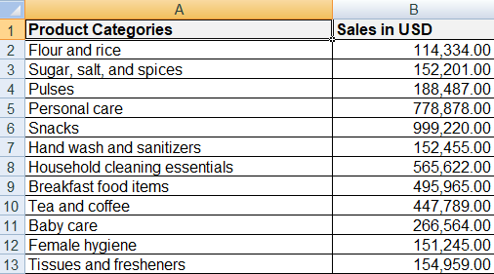
2.3. Product Category wise sales in USD
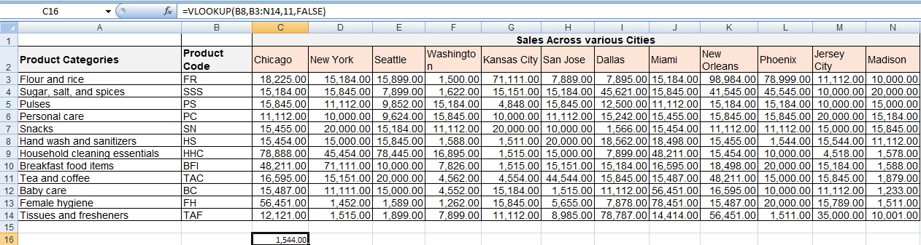
2.4. Sales Across various Cities

Tableau Dashboards

1. Dashboard for senior management for Chicago to view sales of personal care products for the last 6 months.
Observation: For personal care product we notice that March and April were the highest sales and May was the lowest sale.

2. Dashboard to show Senior Management for Chicago to view sales of breakfast products for the last six months.
Observation: For breakfast product we notice that January was the highest sales and April was the lowest sale.

- Dashboard that clarifies the sales of personal care and breakfast product:

EXCEL Dashboards

Question 1:

1. A bar graph showing the sales product wise category.

Ascending order
Descending order
Question 2
1. Bar graphs of sales for zone 1 cities
2. Total sales across all cities
3. More details about each product

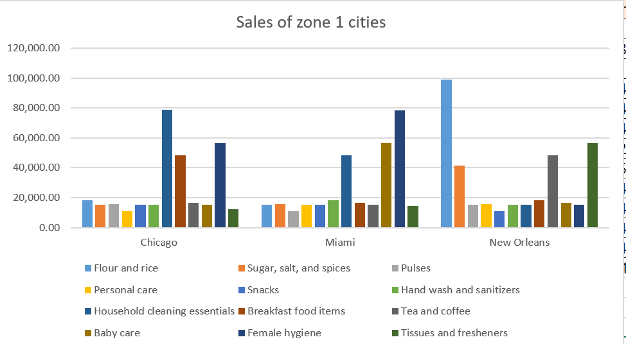

Question 3

1. Using vlookup for product code HS, find sales in Phoenix

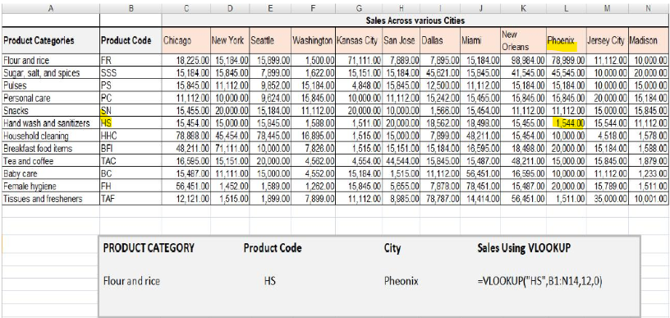

=VLOOKUP(B8,B3:N14,11,FALSE)
= 1,544.00

2.Using vlookup for product code FR, find sales in Dallas
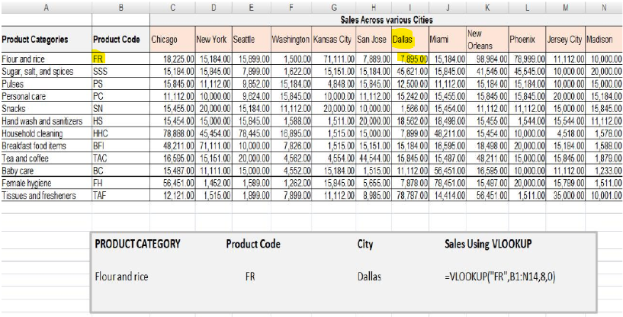
=VLOOKUP(B3,B3:N14,8,FALSE)
= 7,895.00

6. LEARNING THROUGH THE PROJECT

LEARNING THROUGH THE PROJECT:

- As I was having the survey of the company, I realized that most of the new launches requires a lot of data interpretation and analysis.
- The data should be clean and presentable so that it can be analyzed and be relayed upon for further decisions
- Had a hands on practice with using Tableau and its Dashboards.
- Had a hands on practice and experience on using Excel Formulas and Chart formation by using the data.
- Got awareness of the Agile Methodologies for fast, cost effective and time efficient development of the project
- Got the knowledge of various numerous Business Analysis Practices , used for development of any project .
- Knowledge upon, identifying different stakeholders in each project, Determining the flow of the project, for time efficiency and cost reduction.
- Got details upon various Tasks , Techniques , and process followed by the big tech organizations in Business Analysis Domain and Agile Method of working.
- Have gained the skills for Presentations skills, Critical Thinking , and Visualization.

7. CONTRIBUTION TO THE HOST ORGANIZATION
CONTRIBUTION TO THE HOST ORGANIZATION:

- The company improved work environment and infrastructure.
- The company was able to build in the new updated software.
- The company was able to build the new feature on the website.
- The company was able to generate new business field, by starting a whole new process for the pantry.
- The company has seen a growth in revenue since the launch of the project.
- Given the company a heads up to look into more fields to implement on.
- The company could think of hiring more individuals for the new launched project and train more individual for the project for up skilling the candidate’s sills and upgrading the project.
- The company was able to have clear insights of sales of each product.
- The company was able to set targets for each product wise category and achieve a milestone in sales.
- The company was able to decide which products the customers buy according to the customer segmentations and can decide which products or categories require marketing and more attention.

8. REFERENCES
REFERENCES:
The reason to chose the following references is because it has retrieved from various webpage’s of Amazon's official website- Amazon.com. Therefore, there are negligible chances to have biased or manipulated information.

- Amazon. (2020). About Amazon Go and Amazon Go Grocery. Retrieved from:www.amazon.com:https://www.amazon.com/gp/help/customer/display.html?nodeId=GWDXYUM9SFHEISKD

- Amazon. (2020, 08 08). About services. Retrieved 08 08, 2020, from www.amazon.com: https://www.amazon.com/b?ie=UTF8&mode=12767011011

- Amazon, (2020). Amazon Sustainability Retrieved 08 04, 2020 from sustainability about amazon.com: https://sustainability.aboutamazon.com/

- Amazon. (2020, 07 20). Who we are Retrieved 07 20, 2020 from www.aboutamazon.com:https://www.aboutamazon.com/who we are

- Amazon Prime Air (2020). Retrieved from www.amazon.com:https://www.amazon.com/Amazon-Prime-Air/be=UTF8&node-8037720011

- Containers Customer Stories (2020). Retrieved from aws.amazon.com:https://aws.amazon.com/containers/customers/

- Help & Customer Service (2020, 08 08). Retrieved 08 01, 2020, from www.amazon.com:https://www.amazon.com/go/help/customer/display.html?modeld=201894900
- Amazon: The Making of a Giant (2019). Retrieved 08 03, 2020, from www.wsj.com: https://www.wsj.com/graphics/amazon-the-making-of-a-glant/

- Emont, J. (2020, 03 17). Amazon Prioritizes Medical Supplies, Household Staples From Merchants Amid Corona virus. Retrieved 08 01, 2020, from www.wsj.com/: https://www.wsj.com/articles/amazon-poritizes-

- Banker, S. (2019, 06 25). How Amazon Changed Whole Foods. Retrieved from www.forbes.com: https://www.forbes.com/sites/stevebanker/2019/06/25/how-amazon-changed-whole-foods/#6d4b6e7679xtd

- Cuccinello, H. C (2019, 10 01). Jeff Bozos Through the Ages: The World's Richest Person in Photos : Retrieved from www.forbes.com:

- AUTHOR, S. (2020, 04 13). Amazon's Challenges in Delivery Retrieved 08 09, 2020, from:wwww.investopedia.com: https://www.stopedia.com/articles/investilo:020515 why Amazon -pied-dump-ups-and-fedessamnifd-ups asp

- Chhatwal, R. (2019, September 30). Higher shipping cost hit Amazon Stock. Retrieved from investorplace.com: https://investorplace.com/2019/09/impact of higher shipping costs on amazonstock/text:

- Increase in shipping cost can bearish 20sentiment toward $9 Amazon stock text This include a higher proportion, its retail%2 Platform and%2

- Donnelly, K. (2020, 08 07). Shipping Problems? Get 10 Fixes to the Most Common Fulfillment Challenges. Retrieved from www.shopify.ca: https://www.shopify.ca/blog/122517253-mostcommon-shipping problems

- ecommercetips.org (2020, 08 07). 3 Problems with Amazon Inventory Management-And Their Solutions. Retrieved from ecommerce ps.org: https://ecommercetips.org/ problem: with mentor-management/medical-supplies household staples from merchants amid corona virus 11584447888

- Foods, W. (2020), Prime at Whole Foods Market Retrieved from www.whdefoodsmarket.com: https://www.wholefoodsmarket.com/amazon

